Stories Coffee — Executive Summary
POS Sales & Profitability Insights
Based on Stories Coffee POS exports (25 branches; 2025 + Jan 2026).

Problem statement
How can Stories Coffee use POS data to find the biggest revenue/profit drivers and decide what to fix first across branches and products?
Key findings (data-backed)
- Sales are concentrated: top 3 branches contribute 33.4% of total sales and top 5 contribute 45.4% (total sales: 983.1M).
- A few divisions drive most revenue: Cold Bar Section, Frozen Yoghurt, and Hot Bar Section account for ~77.0% of division revenue.
- Beverages outperform food on margin: beverages are 57.4% of revenue with ~77.2% margin vs food at ~63.1%.
- Data issues exist: ~28.0M cost is attached to items with zero recorded revenue (likely missing prices / POS setup). This is profit leakage and also breaks analytics.
- Seasonality is strong: average monthly sales peak in January and drop sharply in June (peak ~7× the low).
Recommendations (next 30–60 days)
- Replicate best practices from top branches (staffing, in-stock, bundles) into mid-tier branches.
- Protect the main revenue drivers: keep the top divisions fully in stock and reduce prep bottlenecks during peak months.
- Fix pricing/master-data immediately for items with cost but zero revenue (missing price, wrong item mapping, comps).
- Improve food profitability: review low-margin items, renegotiate inputs, and adjust prices or bundle to lift margin.
- Plan for seasonality: a June “dip playbook” (lighter labor + targeted promos) and a peak-month capacity plan.
Expected impact (order-of-magnitude)
- +1 percentage point margin improvement on FOOD revenue (~352.2M) adds ~3.5M profit if volume holds.
- Resolving zero-priced / zero-revenue items could recover up to the associated costs (~28.0M) depending on true selling prices.
- Reducing stockouts in the top divisions (≈77% of revenue) usually gives a bigger return than broad, unfocused changes.
Methodology (brief)
- Cleaned and standardized POS exports (names, missing/invalid rows; flagged suspicious prices).
- Aggregated revenue, cost, profit, and margin by branch, category, division, and product.
- Ranked top drivers and flagged anomalies (e.g., cost with zero revenue).
- Selected only the most decision-useful charts for executives.

Selected visualizations (most relevant)
Figure 1. Total profit by branch (where profits are coming from).
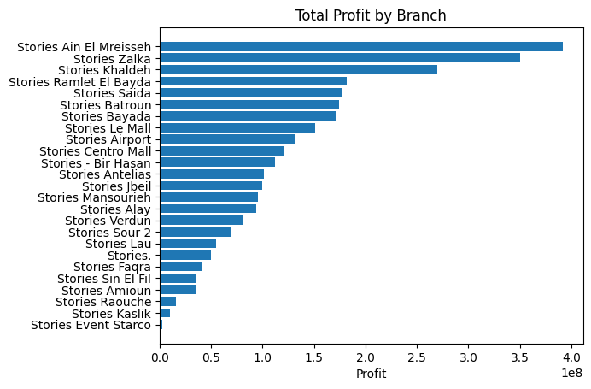
Figure 2. Top groups by revenue (biggest menu levers).
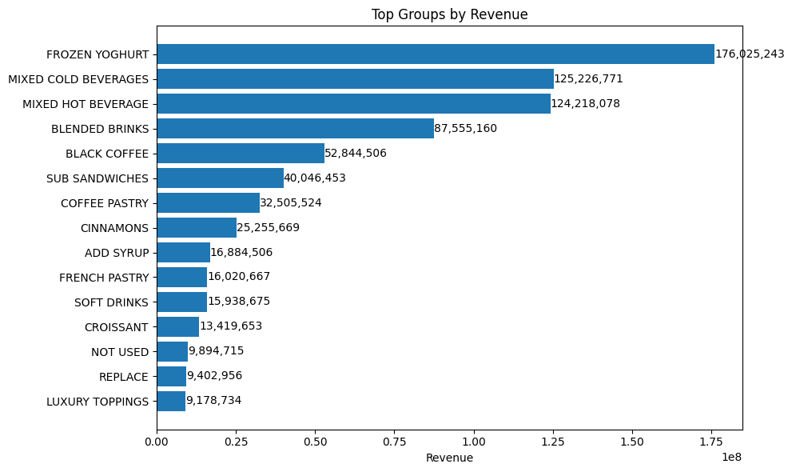
Figure 3. Profit margin comparison: beverages vs food.
